Package Managers

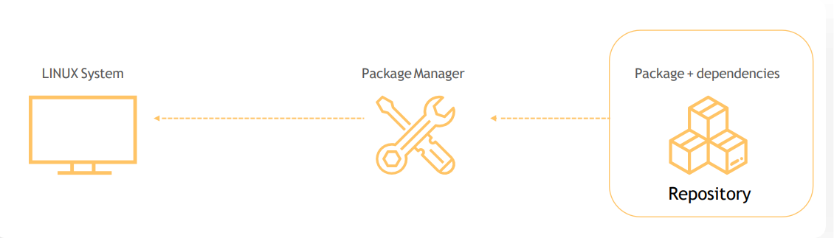

Package management is a software in a linux system that provides a consistent and automated process for installing, upgrading, configuring, and removing packages from the operating system.

There are 2 types of package managers

1. Debian Distributions
2. Red hat Distributions

dpkg 🡪 base package manager for debian distributions

apt 🡪 newer front end for dpkg system

apt-get 🡪 traditional front-end for the dpkg system

rpm 🡪 base package manager for red hat distributions

yum 🡪 front end for rpm

s

working with RPM:

**rpm -ivh telenet.rpm** 🡪for installation

**rpm –e telenet.rpm** 🡪 for uninstallation

**rpm –Uvh telenet.rpm** 🡪 for upgrading

**rpm –q telenet.rpm** 🡪 to query the database and get details about an installed package

**rpm –Vf** <path to file> 🡪 verify a file

*rpm doesn’t resolve package dependencies on its own, for this reason we use higher level package manager called yum.

Yum package manager

* RPM based distros
* High level package manager
* Automatic dependency resolution

Repositories information is stored /etc/yum.repos.d

**Yum repolist** 🡪 shows all your repos added to your system

**Yum install** 🡪 to install

**Yum remove** 🡪 to remove

**Yum update <package name** > 🡪 to update package

**Yum update** 🡪 to update all the packages that installed in the system.

Working with DPKG (package extension id .deb)

**Dpkg –i telenet.deb** 🡪 installation

**Dpkg –r telenet.deb** 🡪 uninstall

**Dpkg –l telenet** 🡪 list all packages

**Dpkg –s telenet** 🡪 status

**Dpkg –p <path to file>** 🡪 to display details about the packages(version number)

APT/APT-GET

**apt install python** 🡪 installing packages

**apt-get install python**

*software repositories for apt is defined in the /etc/apt/sources.list file

**apt update** 🡪 to refresh the repository after installing new OS or adding new sources

**apt remove telenet** 🡪 to remove packages

**apt search telenet** 🡪 used to search for the packages in the repository